The Ceres Trust 2010 Graduate Student Organic Research Grant:
Final Report

1.Project Title: Soil Invertebrate Biodiversity under Contrasting Orchard Management Regimens in Michigan

2. Project Leader: Nathaniel J. Walton, Graduate Student, Michigan State University, Dept. of Entomology

3. Major Professor: Dr. Matt Grieshop, Assistant Professor, Michigan State University, Dept. of Entomology

4. Accomplishments:

Abstract
Healthy soil contains a diversity of microorganisms that perform essential functions such as aeration, decomposition, and biological control of crop pests. Entomopathogenic nematodes (EPNs) are tiny insect parasites that can be applied with water using conventional sprayers and can kill their insect hosts within only a few hours after infection. The codling moth (Cydia Pomonella [L.]) is a serious insect pest of apples worldwide and is of critical concern in organic apple production. Codling moth larvae pupate and overwinter in silk cocoons in soil litter and on tree trunks or branches. EPNs have potential for management targeting codling moth larvae since they actively search out hosts in protected locations. National Organic Program (NOP) approved formulations of EPNs are available for management of a variety of pests. We have been evaluating the EPN species, Steinernema feltiae (Filipjev) at three Michigan organic apple orchards to determine its impact on the orchard soil arthropod community. EPNs are already present in most soils, so applications that augment natural populations could have a variety of impacts on other soil microorganisms. Mites and springtails for example, can feed on nematodes and might benefit from an EPN application. However, other organisms such as beetle larvae are susceptible to EPN infection and could be harmed by EPNs. To date we have found little evidence of any impact of EPN applications on soil ecology in organic orchards. EPN applications had no impact on overall soil arthropod abundance and diversity within organic orchards. Organic orchards also had consistently higher soil arthropod abundance compared to paired conventional orchards, independent of EPN treatment. Indices of arthropod diversity did not differ significantly between orchard management types (organic vs. conventional).

Study Sites
The studies were carried out in six paired (organic and conventional) apple orchards, in Michigan’s southern lower peninsula. These included AlMar orchards located near Flushing, MI, The Country Mill located near Charlotte, MI and the Michigan State University (MSU) Clarksville horticultural research center. Half-acre experimental plots were established at each site after consultation with the growers.

Objective 1: Determine the diversity of soil and leaf-litter invertebrates in organic and conventional apple orchards in Michigan.

Methods
Soil and leaf litter samples were collected with a golf course cup-cutter. Three subsamples from each experimental plot were taken and combined to form one sample from each plot on each sampling date. Each subsample included a 4-inch-deep, vertical section of soil as well as associated leaf litter and plant material. Samples were collected during the 2010-growing season, on three sampling dates: post-bloom (July 13-22), pre-harvest (Aug 2-19), and post-harvest (Oct. 4-10).
In the laboratory, samples were placed in Berlese funnels for extraction of invertebrates into 80% Ethanol. Identification of specimens was performed using a binocular dissecting microscope. Specimens were identified to the lowest taxonomic level possible using available taxonomic keys.

Results
Farm management (organic vs. conventional) had no statistically significant effect (P>0.05) on arthropod diversity as measured by the Shannon-Wiener index (H, Fig. 1), evenness (E), Simpson’s Index (D), or species richness (data not shown). However, arthropod abundance was significantly higher in organic apple orchards than in conventional orchards (Fig. 2).

Objective 2: Determine the effect of entomopathogenic nematode applications on the diversity of soil and leaf-litter invertebrates in organic apple orchards.

Methods
The entomopathogenic nematode Steinernema feltiae in an organic formulation (Bionem® F, Becker-Underwood, Ames, IA) was applied at 2 commercial organic farms in codling moth infested apple orchards (Charlotte, MI and Flushing, MI). Four treatments were applied at each site in a randomized complete block design with 3-4 experimental replicates at each site. The four treatments were: an untreated control, a nematode application targeting the 1st generation of codling moth (Mid-July), an application targeting 2nd generation codling moth, and a treatment combining the two timings (i.e. one application in July and another in August). Soil samples were collected from treated and control plots in August using the methods outlined above (Objective 1) and the arthropod communities were compared statistically between treated and untreated plots.

Results
Nematode application had no statistically significant effect (P>0.05) on arthropod diversity or abundance in organic apple orchards in this study (Figs. 3 and 4). However, the sample size was small (n=12) and the variance within individual groups of arthropods (e.g. mites) was high among field sites and sampling dates. A repeat of this study with a larger sample size might confirm that applications of S. feltiae have no significant effect on the soil arthropod community.

Statistical Analysis
Species richness, the Shannon-Wiener diversity index, and Simpson’s D were calculated for each sample. Diversity indices and abundances were compared between management types using a two-way ANOVA, with a model that included sampling date, management type, and their interaction. Arthropod abundance was log₁₀(x+1) transformed to meet the ANOVA assumptions prior to analysis. A one-way ANOVA was used to compare diversity indices in nematode treated plots to non-nematode treated plots within organic apple orchards.

Objective 3: Develop extension materials and online resources to educate the public about the ecology of soil and leaf-litter fauna.
The preliminary results of this research were presented in a research poster at the Midwest Organic and Sustainable Education Service (MOSES) conference in LaCrosse, WI in February 2011. In addition, the undergraduate student working on this project (Michelle Brosius) created digital images of representative specimens of each group, which have been incorporated into an orchard soil food web diagram (Fig. 5). This image has been incorporated into a document containing figures generated by this research (e.g. Fig. 6), which we will publish in print and online for dissemination to the public. The soil-food web diagram was also included in a handout that was distributed to growers at an Organic Tree Fruit Association field day at AlMar orchards in Flushing, MI in August 2011.

Figures
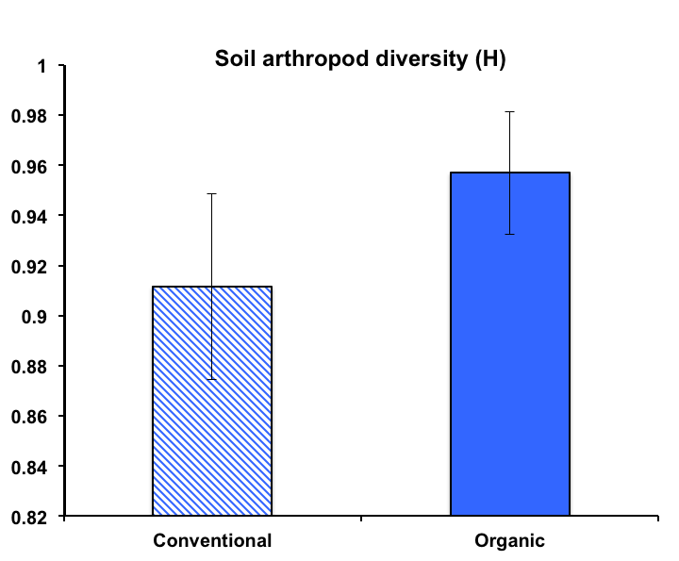
Mean soil arthropod diversity (+/- SEM)
Figure 1. Soil arthropod diversity in Michigan apple orchards under either conventional or organic management. Mean diversity as measured by the Shannon-Wiener index (H) was not significantly different between management types (P>0.05).
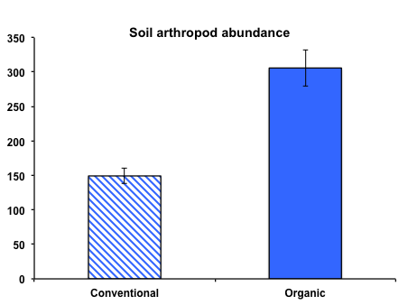
Mean soil arthropod abundance (+/- SEM)
Soil arthropod abundance

b
a
Figure 2. Soil arthropod abundance in Michigan apple orchards under either conventional or organic management. Log₁₀(x+1) transformed arthropod abundance was significantly higher in organic orchards than conventional orchards (P<0.05).

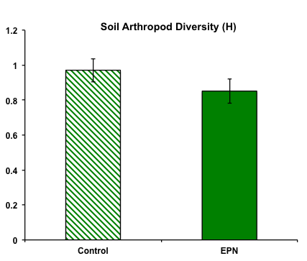
Mean soil arthropod diversity (+/- SEM)
Figure 3. Soil arthropod diversity in Michigan organic apple orchard plots treated with entomopathogenic nematodes (EPN) or untreated (Control) in August 2010. Mean diversity as measured by the Shannon-Wiener index (H) was not significantly different between treatments (P>0.05).
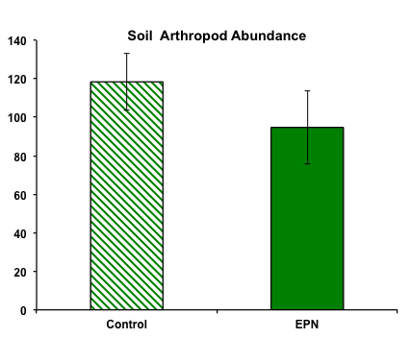
Mean soil arthropod abundance (+/- SEM)
Figure 4. Soil arthropod abundance in Michigan organic apple orchard plots treated with entomopathogenic nematodes (EPN) or untreated (Control) in August 2010. Abundance was not significantly different between treatments (P>0.05).

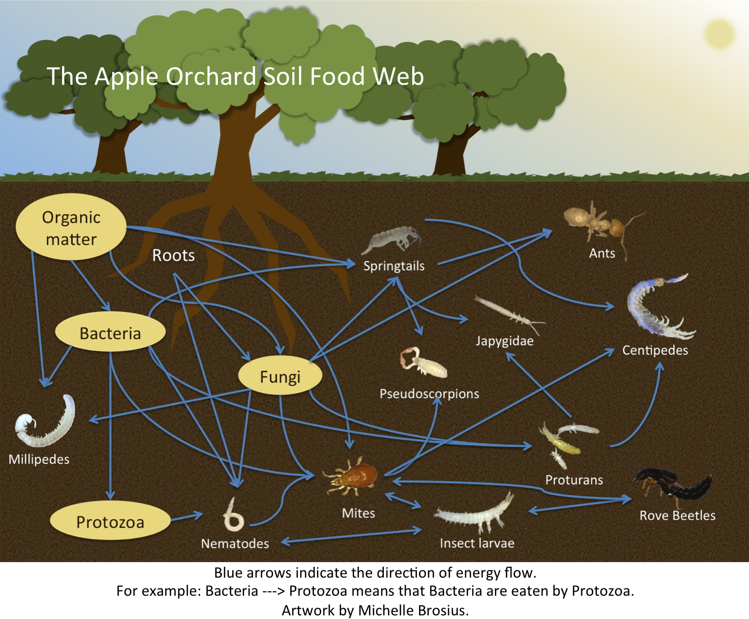

Figure 5. Diagram of the soil food web in organic apple orchards.

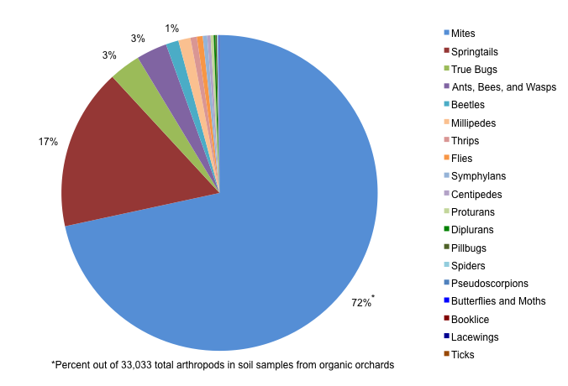
Organic orchard soil arthropod community
Conventional orchard soil arthropod community
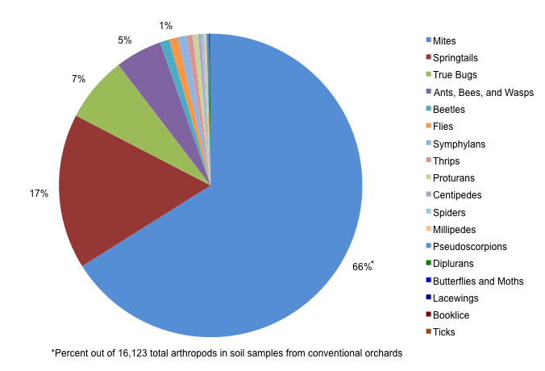

Figure 6. Arthropod community structure in soil samples from organic and conventional apple orchards in Michigan. Data are pooled from samples collected in July, August, and October 2010.

