This is a final project report submitted
to the Ceres Trust.

Project Title:

Perceptions and Use of Organic Seed and Varieties by Midwestern Organic Vegetable Growers

Graduate Student Grant Recipient:

Alexandra Lyon
PhD Candidate in Environment and Resources
Nelson Institute for Environmental Studies
University of Wisconsin-Madison
308F Agricultural Hall
1450 Linden Drive
Madison, WI 53706

Faculty Advisor:

Erin Silva
Organic Research Scientist
Department of Agronomy
University of Wisconsin-Madison

Faculty Co-Advisor:

Michael Bell
Community and Environmental Sociology
University of Wisconsin-Madison

Ceres Trust funding awarded: $9584.00

Project Period: 2011 - 2012

Report Submitted: July 2012, 9 pages

Project Summary
This project is an investigation of Upper Midwester organic farmers’ experiences, perspectives, and opinions in the realm of vegetable seed and plant breeding. Using a mail survey of 220 organic vegetable growers in the Upper Midwest, we posed questions about growers’ seed use and purchasing decisions, opinions about plant breeding priorities, participation in on-farm research, and similar topics. We also explored these questions in further depth through qualitative interviews with selected growers. Results of this analysis will be use in Alexandra Lyon’s dissertation for a PhD in Environment and Resources. We will also seek publication in appropriate scholarly journals and develop a research brief that will be made available to farmers and the general public through the University of Wisconsin’s Center for Integrated Agricultural Systems.

Problem Addressed

The overarching goal of this project is to provide a better understanding of seed use and needs among organic vegetable growers in the Upper Midwest. Organic seed in the United States is at a crucial juncture characterized by two simultaneous developments in the seed industry. The first is that decades of aggressive consolidation among mainstream seed companies have produced widespread uncertainty about the consistent availability of vegetable varieties. Loss of access to appropriate varieties is especially concerning for vegetable growers outside of the wholesale conventional market, including direct-market farmers, CSA, small- to mid-scale farms, and organic growers. The second trend is the emergence of an organic seed sector consisting of a small but growing number of regional seed companies specializing in organic and untreated seed, the rediscovery among farmers and home gardeners of heirloom and open-pollinated varieties, and renewed interest in skills of seed production.

In order to strengthen this emerging organic seed sector and improve the availability of high-quality organic seeds, there is a growing interest in developing participatory and on-farm plant breeding, bolstering public plant breeding programs to include organic breeding, establishing community seed banks and exchanges, and teaching seed saving techniques. If any of these approaches are to be broadly successful, however, the needs and experiences of organic farmers need to be better understood.

There is a need for better information about how changes in the seed industry are affecting organic farmers on the ground, and about farmers’ interest in and barriers to engaging in on-farm plant breeding, variety trials, and/or seed saving. Furthermore, since both the performance of crop varieties and the feasibility of seed production are highly dependent on climate and other local environmental factors, it is vital to understand farmers’ perspectives on a regional scale. Our research treats the Upper Midwest as a case study to investigate these questions within a specific grower community.

Project Objectives

Objective 1: Investigate organic grower experiences and opinions using a mail survey.
Our objective was to understand farmer experiences and opinions in order to guide future plant breeding efforts, inform organization efforts in the organic seed movement, and steer outreach and education. Our survey questions focused on five main topics:

- Factors influencing farmer choices of vegetable varieties.
- Access to and quality of organic seed;
- The influence of certifiers, seed companies, and end markets on decisions about using organic seed;
- Additional factors such as cost, impact on organic integrity, impact on consumer perceptions, etc., and
- Factors influencing grower participation in collaborative research.

Objective 2: Document and examine the perspectives of key farmers through in-depth qualitative interviews.
In addition to the mail survey, our second objective was to deepen our understanding of grower perspectives using qualitative sociological methods, specifically semi-structured interviews. While surveys provide a powerful and statistically useful tool for obtaining a general view of a population, surveys are also limited in important ways, including the ability to follow up on respondent’s answers or ask questions that are in the researcher’s blind spot. We therefore turn to qualitative interviews to develop a richer and more nuanced analysis and to document individual grower stories as case studies in the ways that Upper Midwestern organic farmers are responding to the current shape of the seed industry.

Objective 3: Use outreach and public events to continue a conversation about seed in the organic grower community.
Our third objective was to involve organic farmers in our investigation and promote the visibility of seed issues in the organic grower community. We sought to accomplish this by discussing our survey and results at grower workshops and field days such as field days at the West Madison Agricultural Research Station and presentations at the Organic Farming Conference in Lacrosse, WI. We also sought to involve farmers in the creation of the survey tool and solicit preliminary feedback on our survey questions from selected farmers. Finally, we aim to make the results of this survey available to the farming community through the publication of a research brief in collaboration with the Center for Integrated Agricultural Systems (CIAS) at the University of Wisconsin-Madison.

Methodology

1. Wisconsin Organic Vegetable Seed and Plant Breeding Survey
The survey was designed in consultation with the University of Wisconsin-Madison Survey Center and with a statistics consultant from the College of Agriculture and Life Sciences. Survey topics and questions were developed with input from plant breeders and farmers. We also reviewed similar grower surveys conducted by other organizations, including several by the Organic Farming Research Foundation and a recent national survey of organic plant breeding needs conducted by the Organic Seed Alliance. We solicited feedback from Organic Seed Alliance staff regarding any changes they would have made based on the response to their survey. A test version of the survey was then sent to four farmers and one survey consultant, who filled it out and provided detailed feedback. Based on this feedback, we were able to clarify the questions and make them easier to answer.

The final survey consisted of 29 questions covering demographics, farm characteristics and practices, and farmer opinions. It was sent to a mailing list of 220 farmers, compiled with the help of the Midwest Organic and Sustainable Education Service (MOSES). On the advice of the UW-Madison Survey Center, we sent an announcement postcard about 2 weeks before mailing the survey. Numbered envelopes were used track responses while maintaining respondent anonymity. People who did not return the survey after the first mailing were sent a second copy. The timeline of mailings was as follows:

January 4, 2012 First announcement postcard mailed
January 28, 2012 First round of surveys mailed
February 24, 2012 Second announcement postcard mailed
March 2, 2012 Second round of surveys mailed

Of the 217 surveys sent, 9 turned out to be to invalid addresses. Of the remaining 208 surveys sent to valid addresses, 97 were returned after the first mailing and 37 after the second mailing, for a total of 135 returned as of this report, though more may still arrive. This response rate of 64.4% is very high in comparison with typical expected response rates in survey research.

Survey results were entered into digital form using Excel and analyzed using Stata, a statistical software that is ideal for handling survey data. The first step in analysis was to remove or reinterpret cases where surveys were filled out improperly. After the data was cleaned in this manner, descriptive statistics could be determined for variables of interest. In the future, we plan to use methods such as cross-tabulation and regression to examine how questions were answered by respondents in different groups, such as farm size, farmer education level, or primary market venues.

2. Qualitative Interviews
The interviews are being carried out using a grounded theory approach, a social science methodology which emphasizes iterative sampling and question design. Initial interview participants were recruited through our existing networks of farmers, with an eye towards finding farmers who spanned a range of characteristics such as farm size, primary market venue, age, gender, and farming experience. Some participants were also recruited at outreach events, such as at our workshop at the Midwest Organic Farming conference. Further participants were recruited using the technique of “snowball sampling,” or asking interview respondents to suggest other farmers to interview. Analysis will be developed through a methodical reading of the interview transcripts to look for recurrent “codes,” or key themes, which are then used to construct an analytical framework. As a framework is developed, it will be tested further through subsequent interviews which seek to challenge emergent hypotheses.

Results

Population characteristics

Out of 91 usable responses to our survey, 84 were certified organic, 2 were transitioning to organic, and 5 identified themselves as following organic practices but not certified. The mean number of years certified was 8.6, with a minimum of 2 and a maximum of 27 years certified. Half of respondents grew less than 5 acres of organic vegetables in 2011, and another 27% grew between 5 and 12 acres (Figure 1, p. 8). The mean number of crops grown on participating farms was 22, although there was considerable variation in this area, with one farm growing only a single crop (peas for canning) and others growing up to 150 different crops. Farmers tended to be middle-aged, with 55% of growers between the ages of 41 and 60. There was, however, a considerable number of younger growers: roughly 25% of respondents were 40 or younger. About a quarter of respondents were women. Our respondents were also highly educated: of the 86 who answered the question about education level, nearly 70% had attended university and 29% had attended graduate school.

Notable findings

Preliminary descriptive statistics of selected variables show interesting patterns that we plan to explore further. With regards to use of organic seed, a surprisingly high percentage of respondents (28.9%) reported that over 80% of the cultivars they used in 2011 were in the form of organic seed, and over half of the growers (66%) reported that more than 40% of their cultivars were from organic seed (Figure 2, p.8). Half of the respondents reported that their organic certifier had requested that they take greater steps to source organic seed in the last 3 years, and a few commented positively on the increasing availability of organically produced seed. Opinions varied widely about the ease of accessing organic seed with satisfactory seed quality, but there was some consensus that it was somewhat difficult to access organic seed with satisfactory traits (Figure 3, p.9).

Regarding crop priorities, growers were asked to identify the most important crops in terms of income-earning potential as a non-CSA crop, and in terms of importance as part of a diversified CSA basket. Tomatoes were by far the most important crop in both categories. The next most important crops in terms of non-CSA value were potatoes, cucumbers, winter squash, and beets, all of which were fairly evenly ranked by growers. In terms of general importance to the farm (i.e. CSA value), the next most important crops after tomatoes were lettuce, carrots, potatoes, and green beans. Further analysis will determine the statistical significance of these differences, but the divergent answers between CSA- and non-CSA crops point to the importance of market venues in determining crop research priorities. Market venue was included in the survey and in subsequent analysis we will be able to parse out how growers with different marketing strategies prioritized crops differently.

In terms of plant breeding priorities, disease resistance appears to have been the most frequently cited priority. Further analysis will allow us to evaluate the significance of the next most frequently named priorities, which included yield, flavor, season extension, and seedling vigor. We will also be able to break down priorities by specific crops. Interestingly, responses were fairly evenly split around the question of open-pollinated versus hybrid varieties, with nearly equal percentages of respondents agreeing and disagreeing with the statement “I prefer to use open-pollinated varieties rather than hybrid varieties.” Nonetheless, the majority of growers agreed with the statement “Developing open-pollinated varieties should be a priority for plant breeding for organic agriculture (Figure 4).”

Plans for Further Analysis

Further analysis will focus on the relationships between the population characteristics and the dependent variables discussed above. For instance, we will be able to examine whether opinions about breeding priorities, open-pollinated varieties, or participatory research bear any relationship to education level, farm size, or market venue. We will also be able look for variables that might explain differences in use of organic seed or on-farm seed saving. We will compare the results of our survey with those of surveys that have asked similar questions of other grower groups, in order to get a sense of how typical our findings are. Finally, we will place our survey results in the context of the findings from ongoing qualitative interviews, which have already begun to show the diverse range of grower opinions about seed issues.

Conclusion

Thanks to funding from the Ceres Trust that allowed us to conduct the survey and travel to interviews and outreach events, this project has produced a valuable dataset for studying the perspectives and practices of Upper Midwesterm organic vegetable growers. Based on our preliminary round of analysis, we believe that it will provide useful insights for groups and individuals working to strengthen the availability and security of high-quality organic seed and plant breeding both in the Midwest and other regions. Importantly, the results of our survey provide concrete insights into the reality of the seed sector for farmers in the specific growing region of the upper Midwest. Because organic farming depends on local adaptation, this regional approach is an important supplement to broad, national studies.

Outreach

Public Events

We have had encouraging farmer response to public events held in relation to this project. At the 2011 Organic Farming Conference in Lacrosse, WI, we had a roundtable discussion on organic seeds and varieties. Comments from the nearly 30 farmers and researchers who attended the discussion led us to plan a full workshop session at the 2012 conference. That workshop, which focused on organic variety trials and plant breeding, was attended by 93 people. Interest and discussion were strong, and several farmers approached us to volunteer as interview participants. Many of our interview participants have expressed interest in learning more about on-farm seed saving and plant breeding. In August 2012, we will be hosting a plant breeding workshop for organic farmers in Madison, in coordination with partners from the Northern Organic Vegetable Improvement Collaborative. Farmers who participated in the survey and interviews will be invited to this event, and it will be an opportunity to publicize the results of our survey.

Plans for Publication

The data from this survey and from the qualitative interviews will form the basis for a chapter of Alexandra Lyon’s dissertation in satisfaction of the requirements for a PhD in Environment and Resources from the Nelson Institute for Environmental Studies. I expect to complete this degree by summer 2013, and will seek to publish as many chapters as possible in appropriate academic journals. We also plan to publish a shorter paper based on the survey alone at an earlier date. We believe that agronomic and sustainable agriculture-focused publications such as the Journal of Sustainable Agriculture will be interested in our findings. In order to make our results available to the farming community and the non-academic public, we will also publish a shorter version in the format of a research brief through the University of Wisconsin Center for Integrated Agricultural Systems (CIAS). This research brief will be made available online and the print version will be distributed at workshops, conferences, and by mail to interested farmers.

Addendum: Tables and Figures

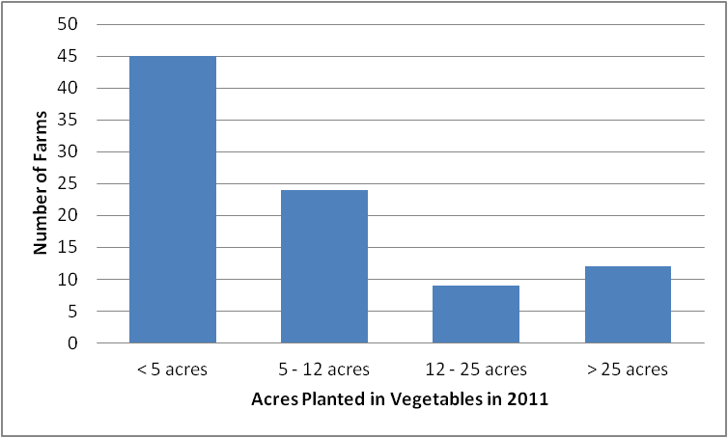
Figure 1. Scale of vegetable production in 2011 by number of farms responding in each scale category, out of 90 responses.

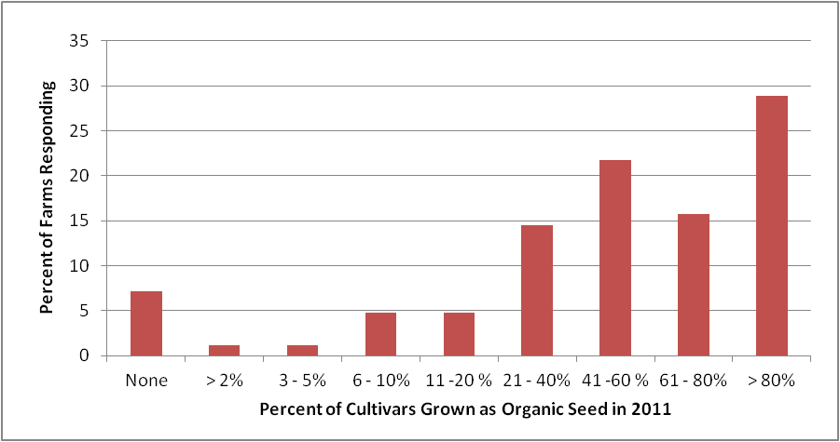
Figure 2. Percent of cultivars grown as organic seed in 2011 by percent of farms responding, out of 83 responses.

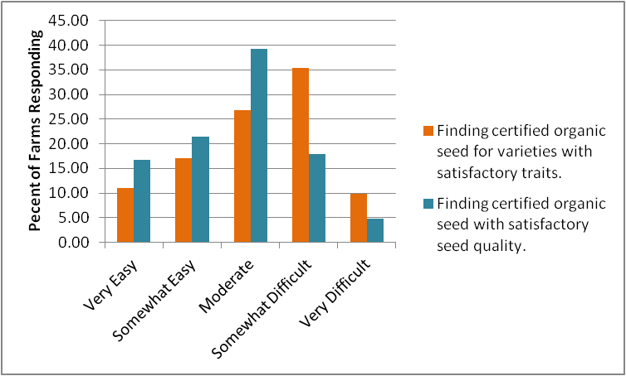
Figure 3.Opinions about access to organic seed with satisfactory traits and seed quality, by percent of farms responding, out of 84 responses.

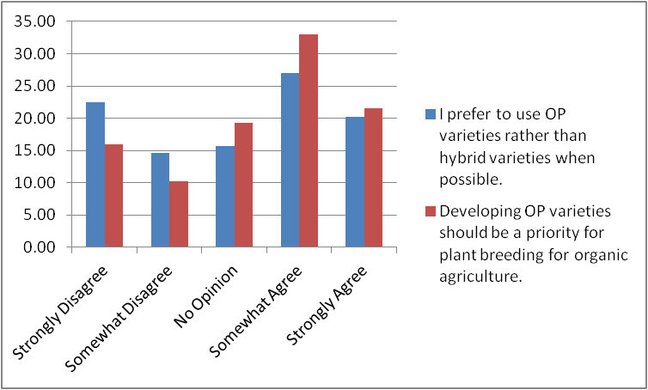
Figure 4. Opinions about open-pollinated and hybrid varieties by percent of farms responding, out of 88 responses.

