CERES Title Page
2010 Graduate Student Grant Program

Title: Benefits of increasing grazing height on weed suppression in management-intensive rotational grazing systems in Wisconsin.

Graduate Student:
Name and Title: Marie Schmidt
Organization: University of Wisconsin, Madison Phone: 414-467-3597
Address: 1575 Linden Dr.
City, State, Zip: Madison, WI 53706
E-mail:marie.schmidt5@gmail.com

Faculty Advisor:
Name and Title: Mark Renz
Organization: University of Wisconsin, Madison Phone: 608-263-7437
Address: 1575 Linden Dr
City, State, Zip: Madison, WI 53706 E-mail: mrenz@wisc.edu

Contracts and Grants Office:
University of Wisconsin-Madison, Research and Sponsored Programs, 21 N. Park Street, Suite 6401 Madison, WI 53718-1218

Authorized Organizational Representative:
Cheryl Gest, Managing Officer RSP Phone: 608-262-3822
21 N. Park St, Suite 6401 Fax: 608-262-5111
Madison, WI 53715-1218 E-mail: preaward@rsp.wisc.edu

Goal 1: pages 2-25
Goal 2: pages 26-30

Goal 1 as stated in proposal: Evaluate weed establishment from livestock implemented grazing heights.

The results from the livestock implemented grazing heights were combined with results from a simulated grazing event. In addition to a thesis chapter the results were shared with farmers at mettings/conferences.
Grassworks LLC Annual Meeting, Wisconsin Rapids, Wisconsin, February 20, 2010. Presentation title: Benefits of increasing grazing height on weed suppression in management-intensive rotational grazing systems in Wisconsin.
Weed Science Society of America Annual Conference, Denver, CO, February 2010. Presentation title: Benefits of increasing grazing height on weed suppression in management-intensive rotational grazing systems in Wisconsin.

Title

Effects of increasing grazing height on establishment of burdock (Arctium minus), Canada thistle (Cirsium arvense) and plumeless thistle (Carduus acanthoides) in management-intensive rotational grazed pastures.

Abstract
Management intensive rotational grazing has many benefits to livestock production, but weeds can infest fields and cause reductions in forage quantity, quality and animal performance. Common burdock (Arctium minus), Canada thistle (Cirsium arvense) and plumeless thistle (Carduus acanthoides), are common pasture weeds in Wisconsin that require management to avoid these adverse impacts. Experiments were established at two sites to determine if increasing grazing heights from fall through spring would reduce emergence and survival of burdock, Canada thistle, and plumeless thistle from seed. Canada and plumeless thistle seedling density was higher in treatments that were grazed to 5 cm in the fall and early spring compared to other treatments at one site. In September, weed seedling survival was minimal, which prevented detections of differences between treatments. Regression analysis demonstrated that this reduction was related to increased intercepted photosynthetic active radiation by forage in April. Total forage yield was reduced when grazing heights were increased from the 5 cm to the 25 cm treatment. However, no differences in total biomass were observed in the treatments with varying residual heights compared to the 15 cm treatment. Increasing grazing heights in the fall and spring did reduce biomass in November at one site and in May at both sites, but resulted in increased biomass in June compared to other treatments. Forage quality was also reduced by increasing grazing heights, but differences were lower than desired values only in June. Results suggest that increasing grazing heights can reduce emergence of Canada thistle and plumeless thistle, but can also result in reduction in forage quantity and quality at certain grazing events during the year.

Introduction
Management-intensive rotational grazing (MiRG) continues to increase as a management practice for livestock production. Although pastures are competitive with annual weeds, biennial and perennial weeds can become a problem in the upper Midwestern United States, decreasing production and animal performance (Seefeldt, Stephens, Verkaaik, & Rahman, 2005) Weed management by broadcasting herbicides, while typically the most cost efficient approach, is not commonly conducted in MiRG as legumes are an important component to these pastures and this use would reduce populations (Sellers, Vendramini, & Newman, 2007). In addition, many MiRG pastures are under organic management where few herbicides are available and rarely used. As a result, few tools exist to control identified problem weeds in pastures in Wisconsin (Renz, 2006).
Previous research demonstrated that manipulating light interception can decrease establishment of biennial weeds, by preventing their emergence (Kruk, Insausti, Razul, & Benech-Arnold, 2006). This concept has recently been validated in a MiRG system where burdock rosette density was reduced 61-67% by increasing the residual height of forages to 15-20 cm in the fall through summer (Schmidt & Renz, 2010). This reduction in burdock density was found to be related to light interception, with areas with high light interception in the early spring (April) resulting in fewer burdock rosettes (Schmidt & Renz, 2010). However, increasing the grazing height can reduce forage quantity in the fall and spring grazing events. Forage quality was also found to be impacted in the summer by treatments that suppressed burdock.
As these impacts could reduce implementation, focus group meetings with key stakeholders (e.g. farmers, extension agents, state agency staff) were held in 2009 to determine if treatments could be modified to limit these effects. Results from 2009 research were presented and a discussion was facilitated with attendees to develop treatments to test in 2009-10. The group selected treatments based on practicality and potential to reduce forage yield and quality losses. Additionally the group recommended studies be conducted utilizing livestock to implement treatments on a range of common pasture weeds. Based on the results from the focus group we developed experiments in 2009 to test if 1) identified implementable grazing management techniques reduced emergence and survival of Canada thistle, plumeless thistle, and burdock, 2) if canopy light interception is associated with weed seedling density, 3) determine the effect of treatments forage quantity and quality, and 4) measure if the weed seedling response is similar when treatments are implemented by livestock.

Materials and Methods
Simulated Grazing Trial
Field experiments were conducted from the fall of 2009 through the summer of 2010 at Badger Agricultural Research Station and Franbrook Research Farm in Prairie du Sac and New Glarus Wisconsin, respectively. Additional field sites included Krusengrass Dairy Farm and Lancaster Research Station in Delavan and Lancaster, WI, respectively. All sites had been pastures for > 5 years and were dominated by cool season grasses. Details of each site are summarized in Table 1.
All studies conducted at Badger and Franbrook used simulated grazing (clipping) to implement treatments. While environmental and physical factors can respond differently in grazed versus clipping areas (Schmidt 2010), the use of simulated grazing allowed us to vary the canopy and resulting light interception in specific levels that are similar to grazed situations. This controlled manipulation of residual height allowed us to test our hypothesis on a range of treatments. These experiments could not have been conducted at these locations with livestock because of economic and infrastructural limitations (Kirby, Hanson, Krabbenhoft, & Kirby, 1997; Rinella & Hileman, 2009).

Table 1: Soil type and forage species composition for simulated grazing trial (Badger and Franbrook) and livestock grazing trials (Krusengrass and Lancaster).

 | Badger | Franbrook | Krusengrass | Lancaster
Soil Type | Richwood silt loam | Arenzville silt loam | McHenry silt loam | Fayette silt loam
Forage species | Kentucky bluegrass  (Poa pratensis),  tall fescue (Festuca arundinacea) | meadow fescue (Festuca elatior),  perennial rye (Lolium perenne),  orchard grass (Dactylis glomerata) Kentucky bluegrass  (Poa pratensis) | Orchard grass (Dactylis glomerata), Kentucky bluegrass (Poa pratensis) | Tall fescue  (Festuca arundinacea), orchard grass  (Dactylis glomerata)

Five simulated grazing treatments were established at each site in November of 2009 and maintained throughout 2010 in a randomized complete block design with four replications. Plots were 6 by 6 meters and fenced to separate treatments from active grazing in nearby fields. Treatments compared grazing to 5, 15, and 25 cm at each grazing interval with two focus group implementable treatments with varying heights over-time (see Table 2 for detailed timeline for each treatment). Treatments consisted of clipping grass, removing clipped biomass and leaving a specified residual height.

Table 2: Clipping timeline for simulated grazing trial.

 | Residual Grazing Height (cm)
Treatment | Nov 2009 | May 2010 | June 2010 | July 2010 | Aug 2010
5 cm | 5 | 5 | 5 | 5 | 5
5f-5sp-15su | 5 | 5 | 15 | 15 | 15
15 cm | 15 | 15 | 15 | 15 | 15
15f-25sp-15su | 15 | 25 | 15 | 15 | 15
25 cm | 25 | 25 | 25 | 25 | 25

Each plot was cut to the treatment height, and then allowed to re-grow during the rest period until the next simulated grazing event. The simulated grazing was conducted as close as possible to actual grazing timing for rotationally grazed pastures in study sites’ region, but length of rest period varied throughout the season based on plant growth. To ensure adequate weed pressure, 600 pure live seeds/m² of burdock, Canada thistle and plumeless thistle were broadcast into the plots in November 2009.
Weed density was assessed in June of 2010 to determine weed seedling emergence and in September to determine weed seedling survival by placing two 0.5m² quadrats in each plot and counting burdock, Canada thistle and plumeless thistle rosettes that had germinated in 2010.
Intercepted Photosynthetic Active Radiation of forages (iPAR) was calculated from measurement of PAR taken from an AccuPAR model LP-80 ceptometer with integrated probe and microcontroller. Three readings were averaged above canopy and three below canopy from five locations within each plot at each site before and after simulated grazing to represent the range of PAR seen in each treatment. The amount of light the pasture intercepted (iPAR) was calculated using the following equation (Colquhoun, Konieczka, & Rittmeyer, 2009):

% light interception (iPAR) =
((above canopy PAR – below canopy PAR)/above canopy PAR) x 100

iPAR readings were taken at each grazing event from November 2009 through August of 2010. Readings were also taken in early April, before grazing had been initiated to accurately document iPAR following snow melt and prior to any weed or grass growth in the spring. Treatments were initially implemented in November 2009 and approximately every 30 days from May through August 2010.
Forage biomass was measured at each grazing event by collecting forage from four randomly placed 0.125m² quadrats in each plot. Within each quadrat forages were harvested to the treatment height, collected, dried, and weighed to determine yield for various treatments and timings.
The forage biomass collected was used to determine forage quality using near infrared spectrometry (NIRS System Model 6500 Instrument) with a wavelength range of 800 to 2500 nanometers (Corson, Waghorn, Ulyatt, & Lee, 1999). Relative forage quality is determined using the following equation (Undersander & Moore, 2002):

Relative Forage Quality (RFQ) = (DMI, % of BW) * (TDN, % of DM) / 1.23

Where: DMI = dry matter intake
BW = body weight
TDN = total digestible nutrients
Livestock trial
Field experiments to assess if similar results would be observed if livestock implemented treatments were conducted from the fall of 2009 through the summer of 2010 at Lancaster Agricultural Research Station and Krusengrass Dairy Farm. Details of each site are summarized in Table 1.
Four grazing heights were established at each site in November of 2009 and maintained throughout 2010 in a randomized complete block design with four replications. Plots were 5 x 5 meters and located within one paddock at each farm. Cattle were allowed to graze the entire paddock to approximately 15 cm at each grazing interval. Due to the small size of plots we were unable to utilize livestock to graze treatments to 5 cm residual heights, therefore forage was clipped similar to the simulated grazing trials. We compared consistently grazed heights of 5 and 15 cm at each grazing event with treatments where grazing height was altered from fall to spring. Variable grazing height treatments included a 5 cm fall height that was increased to 15 cm in the spring through summer and a fall height of 15 cm that was reduced in only the first spring grazing event to 5 cm (Table 3). All treatments were implemented based on plant development, or when forages recovered sufficiently to implement grazing heights.

Table 3: Grazing timeline for livestock trial.

 | Residual Grazing Height (cm)
Treatment | Nov 2009 | May 2010 | June 2010 | July 2010 | Aug 2010
5 cm | 5 | 5 | 5 | 5 | 5
5f–5sp–15su | 5 | 5 | 15 | 15 | 15
15 cm | 15 | 15 | 15 | 15 | 15
15f-5sp-15su | 15 | 5 | 15 | 15 | 15

At Lancaster Research Station 600 pure live burdock seeds/m² were broadcast into plots in November 2009. Krusengrass Farm had high burdock seed density already present in the seedbank so no additional weed seed was added. Weed density counts were conducted in June and September 2010 by placing two 0.5 m² quadrats randomly within each plot and counting individual burdock rosettes.
PAR readings were taken at each grazing interval following treatment implementation and also in April before livestock grazing had begun. The same equation as in the simulated grazing trial was used to determine iPAR values at each grazing event.

Statistical Analysis
Weed densities, iPAR, forage biomass and forage quality at each simulated grazing event were subject to analysis of variance (ANOVA) at each time interval for each site separately. In addition forage biomass was summed across grazing events and additionally analyzed with ANOVA. Student’s t-test at p < 0.05 was used for mean separations when appropriate with each of these variables. Linear least squares regression analyses were also utilized to compare the relationship between weed density and iPAR. Significance of slopes from 0 were tested using an F-test (p<0.05).

Results and Discussion
Weed response to simulated grazing
Weed density was assessed in June of 2010 to determine burdock, Canada thistle and plumeless thistle emergence and survival. Burdock did not germinate at any of the locations regardless of treatments therefore differences in emergence and survival was not tested. Weed counts in June were combined for the 5 cm and 5f–5sp–15su treatments because prior to weed counts there were no differences between treatments at this timeframe. In June at Badger a 100% reduction in Canada thistle seedling density was observed in treatments that left 15 or 25 cm of residual height in the fall and spring compared to treatments that left the 5 cm of residual forage (Table 4). Plumeless thistle seedling density at Badger was also reduced with 67% reduction from treatments that left 15 or 25 cm compared to 5 cm of residual forages (Table 4). These results are similar to those found in other studies where emergence of thistle seedlings was negatively correlated with pasture canopy density (Wardle, Nicholson, & Rahman, 1992). Although numeric differences were seen between treatments at Franbrook and they were similar to those observed at Badger, no significant differences were detected. These data indicate that increasing grazing height to at least 15 cm in the fall and in May is sufficient to decrease both Canada and plumeless thistle emergence, compared to treatments that leave 5 cm of residual material. It is not known why we could not detect differences at Franbrook. Possibly the increased number of forage species present at Franbrook (4 species) compared to Badger (2 species) may have provided some additional suppression as others (Biondini, 2007) have documented increased species richness to be involved in preventing weed establishment.
Weed seedling survival was assessed in September 2010 to determine if seedlings that emerged survived throughout the grazing season. A majority of the emerged weed seedlings did not survive through to September and differences between treatments could not be determined (data not shown). Although variable, 43% and 44% higher than normal rainfall occurred in June and July of 2010 in Wisconsin (Young, 2010). While typically Wisconsin pastures experience reduced growth and competitiveness during this timeframe (Carlassare & Karsten, 2002), this was not observed in 2010 and forage species remained productive and competitive throughout the summer. It has been documented that forage species recover more quickly in typical rainfall years (Bryan et al., 2000), and we believe this increase in plant growth gave the forage a competitive advantage over the weed seedlings, causing high levels of mortality.

Table 4. Canada thistle and plumeless thistle rosette density in June 2010 as a result of simulated grazing treatments at Badger and Franbrook.ª

 | Canada thistle and plumeless thistle density (plants/m²) in June 2010
 | Badger |  | Franbrook
Treatments | Canada  Thistle | Plumeless thistle | Canada  thistle | Plumeless thistle
5 cm | 1.5 a | 4.5 a | 1.5 | 1.5
5f–5sp-15su
15 cm | 0 b | 1.5 a | 1 | 1.5
15f–25sp–15su | 0 b | 0 b | 0 | 0.5
25 cm | 0 b | 0 b | 0.5 | 0.5
p-value | 0.03 | <0.01 | ns | ns
ª Means within a column followed by the same letter are not different according to Students t-test at P< 0.05

Light Interception
Light interception varied between treatments just prior to each grazing event. In April, when weed seeds are beginning to emerge, iPAR at Badger in the treatments grazed to 5 cm averaged 56% compared to higher grazed treatments where values were over 85%. However, at Franbrook, where there was lower weed emergence we did not see differences in April iPAR values between treatments and values were 14% higher than Badger, levels that have been shown to suppress burdock (Schmidt & Renz, 2010) (Figure 1). While iPAR values at Badger in the 5 cm treatments did increase by May, emergence of these species of concern in pastures has already occurred (Luschei). By June, the 5 cm treatments had consistently lower iPAR than all other residual heights. This pattern continued throughout the rest of the summer. In contrast the iPAR values of treatments with 15 cm or more residual height remained above 80% at both sites. This demonstrates that leaving at least 15 cm of forage in the fall through the spring will provide consistently higher light interception compared to lower residual treatments, especially in the early spring when most pasture weeds emerge in pastures in Wisconsin.

Figure 1: Intercepted photosynthetic active radiation (iPAR) prior to simulated grazing events at Badger and Franbrookª.
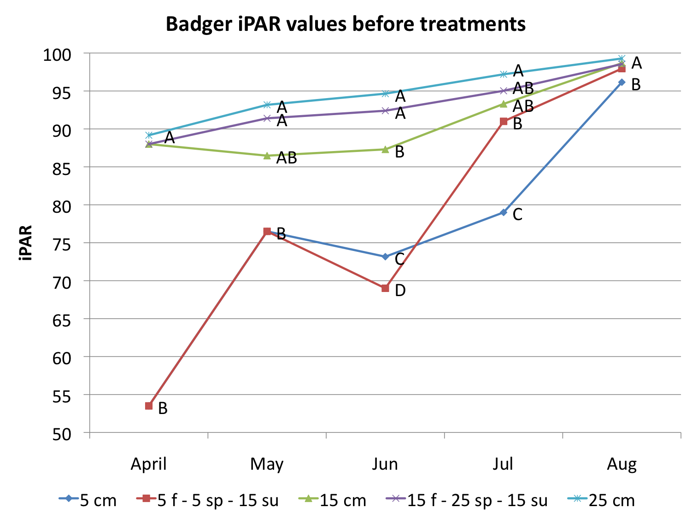
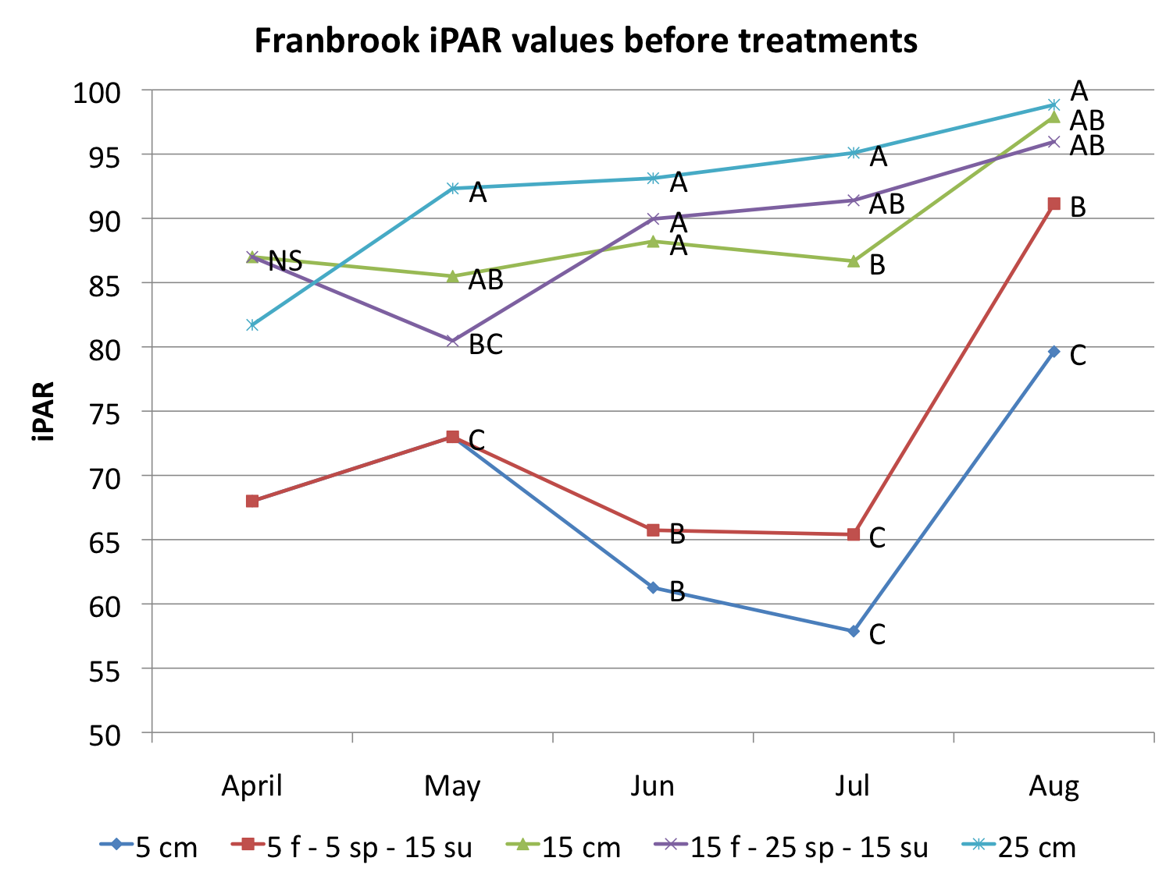
ª Means with similar letters within months are not different according to Students t-test at P< 0.05

iPAR was reduced differentially immediately after applying treatments. Leaving 5 cm of residual forage resulted in 23-62% of light interception, while treatments that left additional forage intercepted substantially more light. For example, treatments that left 25 cm of residual height consistently intercepted 90% or more of the light throughout the season (Figure 2). Treatments with lower residual heights the previous grazing event did intercept less light than treatments that were continuously grazed to the same heights. This is evident in 5f–5sp–15su treatment as summer iPAR values remained less (6-30%) than the 15 cm continuous treatment (Figure 1). Others have also suggested that previous grazing height can alter canopy development and closure of the canopy in future grazing events (da Silva et al., 2009). The 15 cm, 15f-25sp-15su and 25 cm treatments all stayed above 66% iPAR throughout the growing season.

Figure 2: Intercepted photosynthetic active radiation (iPAR) immediately following simulated grazing events at Badger and Franbrookª.
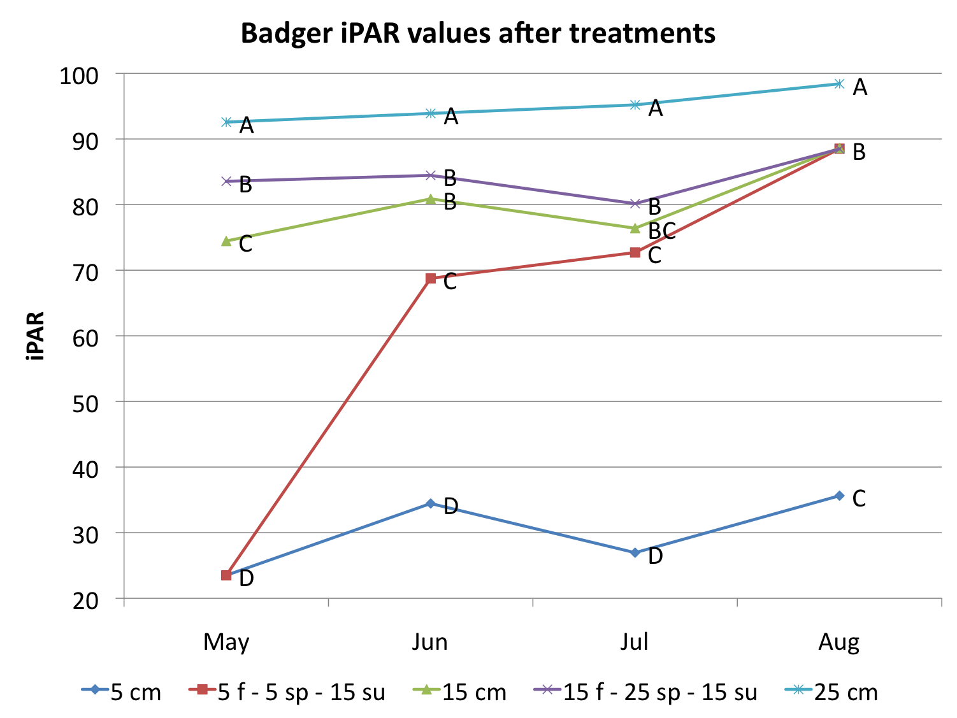
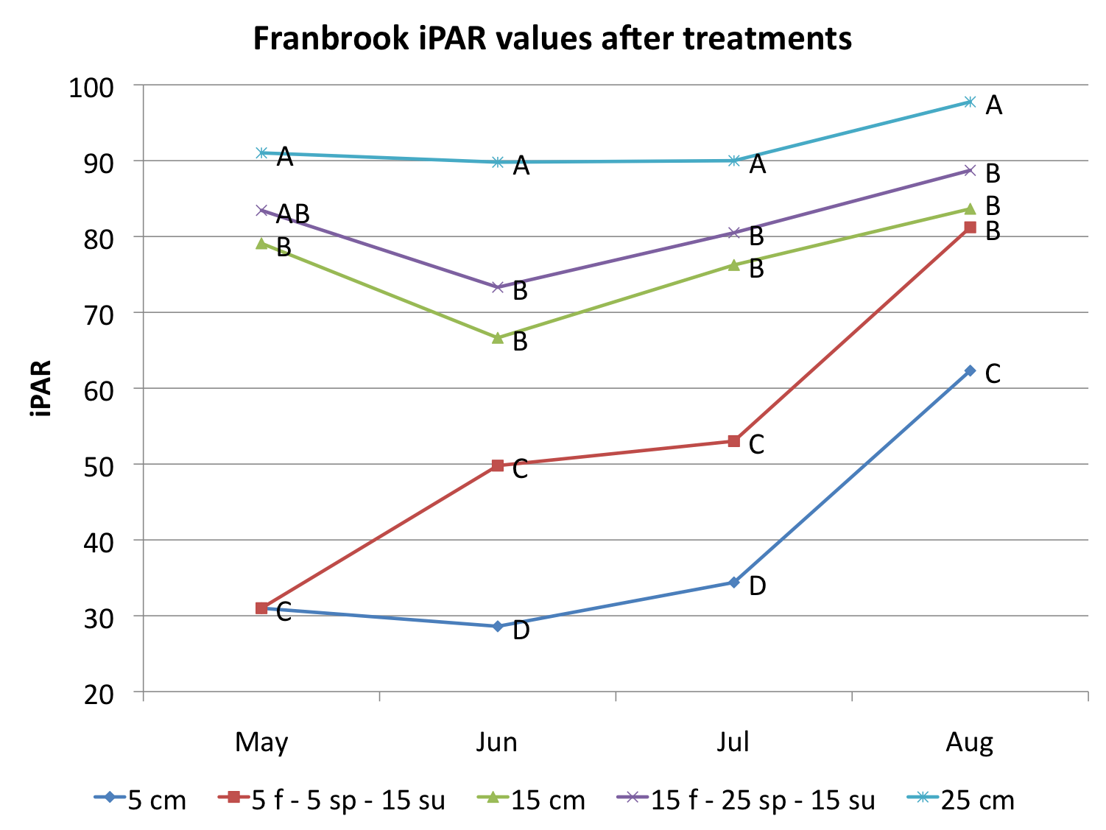
ª Means with similar letters within months are not different according to Students t-test at P< 0.05
Relationship between iPAR and weed emergence

To account for the iPAR variability within treatments we compared June Canada and plumeless thistle density with April iPAR, regardless of treatments. Linear least squares regression analysis showed a significant negative relationship between iPAR and thistle density at Badger (Figure 3), but not Franbrook (data not shown). At Badger we found that when 51% and 57% of the light is intercepted in April (typical for 5 cm treatment), 1.3 Canada thistle and 4.2 plumeless thistle plants/m² are predicted, while increasing the light intercepted to 88% in April (typical for 15 cm and 25 cm treatments) decreased Canada and plumeless thistle density 97% and 81%, respectively. The fact that both sites did not show this trend indicates that site-specific factors may affect this relationship. We believe management of the pasture, especially aspects that can affect early season growth of forages in the spring to be an important aspect in weed establishment in pastures. For example, the 5 cm treatment at Franbrook intercepted 27% more light than the same treatment at Badger (Figure 1). This agrees with other recommendations that promote the selection of the proper forage specie(s) that grow rapidly in the spring and appropriate management of these forages as a critical first step in weed management in pastures (Kruk, et al., 2006; Tozer et al., 2008).

Figure 3: Linear regression of April Intercepted photosynthetic active radiation of forages (iPAR) and June Canada thistle and plumeless thistle density at Badger.

Weed response to livestock grazing
Differences in burdock emergence between treatments could not be detected at either site. At Lancaster, no seedlings emerged in any treatments; this prevented us from comparing differences between treatments. While Krusengrass farms had seedlings emerge, no differences between treatments were detected between treatments or across iPAR in April (Table 5). The lack of differences at this site could be due to many factors, but this site was grazed early in the spring (April 28th) compared to other sites (May 8-May 15). This is during the typical timeframe for burdock emergence in Wisconsin (Luschei) and the decreased iPAR (25-34%) from all treatments likely resulted in emergence and establishment of seedlings. Future research should evaluate the effect of grazing timing on emergence of burdock and other pasture weed seedlings.

Table 5: Burdock rosette density in June 2010 as a result of simulated grazing treatments at Krusengrass Dairy Farm.ª

Treatments | Burdock seedlings/m² (SE)
5 cm | 2 (1.15)
5f–5sp–15su | 2.25 (1.30)
15 cm | 1 (0)
15f-5sp-15su | 0.25 (0.25)
p-value | NS
ª Means within a column followed by the same letter are not different according to Students t-test at P< 0.05

Biomass
The 5 cm continuous treatment was the most productive treatment in total biomass at both sites. However, differences in yield were seen between treatments within season. While differences were variable, generally treatments grazed to 5 cm had 75% and 50-90% more biomass compared to treatments grazed to 15 cm and 25 cm respectively, in November and May, with the exception of Franbrook in November where no differences in biomass were detected. Increasing the grazing height in the spring did affect productivity in June as the 15f-25s-15su treatments had higher biomass compared to all other treatments. By July neither site demonstrated differences in biomass. Our data indicate increasing the grazing height from fall through the early spring, as demonstrated by 15 cm, 15f-25sp-15su and 25 cm grazing treatments (best thistle suppression), would result in a 37% decrease in total forage quantity throughout the grazing season compared to the 5 cm grazing treatment at Badger only (Figure 4). However, the 15f-25sp-15su treatment did not differ in total biomass compared to the 5f–5sp–15su or 15 cm treatment at Badger and did not differ from the 5 cm treatment at Franbrook. This suggests that site-specific management may also determine the degree to which forage in the fall and spring would be sacrificed to obtain weed seedling suppression.

Figure 4: Total dry matter yield of forage in grams/m² at Badger and Franbrook in 2010ª.

ª Means with similar letters within months are not different according to Students t-test at P< 0.05

Quality
Desired relative forage qualities (RFQ) are reported to be from 120 for a cow calf pair to 150 for a lactating dairy cow (Undersander, Albert, Cosgrove, Johnson, & Peterson, 2002). In November, Badger had low RFQ values between 80 and 90, while Franbrook had higher values (between 113 and 135), neither site had differences between treatments (Tables 6 and 7). By the first spring simulated grazing event the RFQ values at both sites were within the desired range for lactating cows with the exception of the 15f-25sp-15su and 15 cm treatments that had RFQ values of 146 and 149, respectively. We believe lower simulated grazing treatments induced the grass to tiller and result in the higher RFQ values as others have observed low grazing to promote new leaf growth (Cullen, Chapman, & Quigley, 2006) that has a higher RFQ value (Paine, Undersander, & Casler, 1999). The lower RFQ values of the 15f-25sp-15su and 25 cm simulated grazing treatments in June through August at both sites were likely a result of increased stem tissue which is known to decrease RFQ (Karn, Berdahl, & Frank, 2006). The effects of increasing grazing heights to 15 or 25 cm reduced forage quality to below optimal values for beef and/or dairy systems in June and July as these treatments had significantly lower RFQ than treatments grazed to 5 cm.

Table 6. Relative Forage Quality throughout the grazing season at simulated grazing events at Badger.ª

 | Relative forage quality at Badger in 2010ª
Treatments | November | May | June | July | August
5 cm | 83 | 153 | 121 b | 140 a | 141 bc
5f–5sp-15su |  |  | 145 a | 137 a | 147 ab
15 cm | 90 | 150 | 114 c | 127 b | 138 bc
15f–25sp–15su | 87 | 150 | 97 e | 117 bc | 151 a
25 cm | 84 | 163 | 104 d | 113 c | 137 c
p-value | NS | NS | <0.01 | <0.01 | 0.02
ª Means within a column followed by the same letter are not different according to Students t-test at P< 0.05

Table 7. Relative Forage Quality throughout the grazing season at simulated grazing events at Badger.ª

 | Relative forage quality at Franbrook in 2010ª
Treatments |  | November | May | June | July | August
5 cm |  | 117 | 196 a | 140 a | 165 a | 149 bc
5f–5sp-15su |  |  |  | 125 a | 166 a | 160 a
15 cm |  | 120 | 197 a | 119 ab | 159 a | 155 ab
15f–25sp–15su |  | 129 | 149 b | 125 a | 151 a | 151 ab
25 cm |  | 135 | 146 b | 102 b | 126 b | 141 c
p-value |  | NS | 0.01 | 0.02 | <0.01 | 0.02
ª Means within a column followed by the same letter are not different according to Students t-test at P< 0.05

Conclusion
Our data demonstrate retaining at least 15 cm of residual height in the fall through the first grazing period in spring (May) can decrease Canada thistle and plumeless thistle emergence compared to treatments that grazed to 5 cm in the fall and spring. Increased light interception, particularly in the early spring (April), appears to be associated with suppression of these thistles, similar to previous studies with burdock (Schmidt & Renz, 2010). Although these thistles can emerge, these populations can be outcompeted by forage, especially in years of good pasture growth (Bryan, et al., 2000). Although increasing grazing heights to 15 cm has the potential to reduce forage quantity at specific grazing events, total forage quantity was only reduced at one site when increasing the residual height to 15 cm. Forage quality may be reduced with higher grazing heights, but this reduction was only observed in June and July. Due to the failure of burdock emergence in our livestock trial, future research is needed to determine how consistent this observed result is when utilizing livestock to implement treatments.

Sources:
AccuPAR model LP-80 ceptometer, Decagon Devices, Pullman, WA
References:
Biondini, M. (2007). Plant diversity, production, stability, and susceptibility to invasion in restored northern tall grass prairies (United states). [Article]. Restoration Ecology, 15(1), 77-87.
Bryan, W. B., Prigge, E. C., Lasat, M., Pasha, T., Flaherty, D. J., & Lozier, J. (2000). Productivity of Kentucky bluegrass pasture grazed at three heights and two intensities. [Article]. Agronomy Journal, 92(1), 30-35.
Carlassare, M., & Karsten, H. D. (2002). Species contribution to seasonal productivity of a mixed pasture under two sward grazing height regimes. Agronomy Journal, 94(4), 840-850.
Colquhoun, J. B., Konieczka, C. M., & Rittmeyer, R. A. (2009). Ability of Potato Cultivars to Tolerate and Suppress Weeds. [Article]. Weed Technology, 23(2), 287-291. doi: 10.1614/wt-08-062.1
Corson, D. C., Waghorn, G. C., Ulyatt, M. J., & Lee, J. (1999). NIRS: forage analysis and livestock feeding. [Conference paper, article]. Proceedings of the New Zealand Grassland Association, 61, 127-132.
Cullen, B. R., Chapman, D. F., & Quigley, P. E. (2006). Comparative defoliation tolerance of temperate perennial grasses. [Article]. Grass and Forage Science, 61(4), 405-412.
da Silva, S. C., Bueno, A. A. D., Carnevalli, R. A., Uebele, M. C., Bueno, F. O., Hodgson, J., . . . de Morais, J. P. G. (2009). Sward structural characteristics and herbage accumulation of Panicum maximum cv. mombaca subjected to rotational stocking managements. [Article]. Scientia Agricola, 66(1), 8-19.
Karn, J. E., Berdahl, J. D., & Frank, A. B. (2006). Nutritive quality of four perennial grasses as affected by species, cultivar, maturity, and plant tissue. [Article]. Agronomy Journal, 98(6), 1400-1409. doi: 10.2134/agronj2005.0293
Kirby, D. R., Hanson, T. P., Krabbenhoft, K. D., & Kirby, M. M. (1997). Effects of simulated defoliation on leafy spurge (Euphorbia esula)-infested rangeland. [Article]. Weed Technology, 11(3), 586-590.
Kruk, B., Insausti, P., Razul, A., & Benech-Arnold, R. (2006). Light and thermal environments as modified by a wheat crop: effects on weed seed germination. Journal of Applied Ecology, 43(2), 227-236.
Luschei, E. Weedometer: A guide to germination of common weeds in Wisconsin Retrieved March, 21, 2008
Paine, L. K., Undersander, D., & Casler, M. D. (1999). Pasture growth, production, and quality under rotational and continuous grazing management. [Article]. Journal of Production Agriculture, 12(4), 569-577.
Renz, M. (2006). [Survey results from Pest Management Update Series in Wisconsin].
Rinella, M. J., & Hileman, B. J. (2009). Efficacy of prescribed grazing depends on timing intensity and frequency. [Article]. Journal of Applied Ecology, 46(4), 796-803. doi: 10.1111/j.1365-2664.2009.01676.x
Schmidt, M., & Renz, M. (2010). The Benefits of Increasing Grazing Height on Weed Suppression in Management-intensive Rotational Grazing Systems in Wisconsin. Paper presented at the Weed Science Society of America, Denver, CO.
Seefeldt, S. S., Stephens, J. M. C., Verkaaik, M. L., & Rahman, A. (2005). Quantifying the impact of a weed in a perennial ryegrass-white clover pasture. [Article]. Weed Science, 53(1), 113-120.
Sellers, B. F., Vendramini, J., & Newman, Y. (2007). Weed management during pasture establishment. University of Florida IFAS Extension.
Tozer, K. N., Chapman, D. F., Quigley, P. E., Dowling, P. M., Cousens, R. D., & Kearney, G. A. (2008). Effect of grazing, gap dynamics, and inter-specific seedling competition on growth and survival of Vulpia spp. and Hordeum murinum ssp leporinum. [Article]. Australian Journal of Agricultural Research, 59(7), 646-655. doi: 10.1071/ar07375
Undersander, D., Albert, B., Cosgrove, D., Johnson, D., & Peterson, P. (2002). Pastures for profit: A guide to rotational grazing. In U. o. W. Extension (Ed.), Board of Regents of the University of Wisconsin System (Vol. A3529, pp. 1-38). Madison: Cooperative Extension Publishing.
Undersander, D., & Moore, J. E. (2002). Relative Forage Quality. from University of Wisconsin Board of Regents
Wardle, D. A., Nicholson, K. S., & Rahman, A. (1992). Influence of pasture grass and legume swards on seedling emergence and growth of Carduus nutans L and Cirsium vulgare. [Article]. Weed Research, 32(2), 119-128.
Young, J. (2010). Wisconsin State Climatology Retrieved 11/20/10, 2010, from http://www.aos.wisc.edu/~sco/clim-watch/index.html#12month

Goal 2 as stated in proposal: Measure differences in germination timing and rate between low and high residual grazing treatments.

These data were used as an appendix to my thesis ,as well as presented to local farmers at a Research Farm Field Day.
Arlington Research Station Pest Management Field Day, Arlington, WI, July 2010. Presentation title: Weed emergence timing and management implications in perennial grass systems compared to traditional row crop systems.

Title

Weed seed germination trial at Arlington Research Station, Arlington, WI.

Weed management in pastures can be difficult, as weeds germinate throughout the growing season and there are few options for control when both legumes and grasses are desired. Additionally, weed germination timing studies in the past have focused on cropping systems where the soil does not have cover in the spring when seeds are germinating. This experiment was set up to determine when burdock (Arctium minus), Canada thistle (Cirsium arvense) and plumeless thistle (Cardus acanthoides) germinate in two different pasture situations, 5 cm residual height and 20 cm residual height, compared to a bare ground system.
Field experiments were conducted from the fall of 2009 through the summer of 2010 at Arlington Agricultural Research Station. The common forage species at Arlington were perennial ryegrass (Lolium perenne) and tall fescue (Festuca arundinacea). The soil type at Arlington is a Ripon silt loam (Fine-​​silty, mixed, superactive, mesic Typic Argiudolls) soil.
Three residual grazing heights were established in October of 2009 and maintained throughout 2010 in a randomized complete block design with four replications. Plots were 1 by 1 meter. Treatments consisted of clipping grass with a sickle bar mower, removing clipped biomass and leaving a residual height of 5 cm (extreme grazing), or 20 cm (light grazing). A bare ground treatment was also included for comparison. Each plot was cut to the treatment height, and then allowed to re-grow during the rest period until the next simulated grazing event. The simulated grazing was conducted as close as possible to actual grazing timing for rotationally grazed pastures in study sites’ region, but length of rest period varied throughout the season based on plant growth. To ensure adequate weed pressure, 450 pure live seeds/m² of locally collected burdock were broadcast into the plots in October 2009.
Weed seedling emergence was estimated several times from May through October by placing a ¼ m² quadrat within the plot and counting and removing all seedlings.

Figure 1: Burdock germination rates at Arlington Research Station in 2010. Blue shading indicates when weedometer.net predicts germination.

Figure 2: Canada thistle germination rates at Arlington Research Station in 2010. Blue shading indicates when weedometer.net predicts germination.

Figure 3: Plumeless thistle germination rates at Arlington Research Station in 2010. Blue shading indicates when weedometer.net predicts germination.

Weed seedling emergence began later than predicted by the weedometer in all treatments, with the exception of burdock, where the 5 cm and 20 cm treatments germinated later than the bareground treatment. Weeds in pastures may germinate later than weeds in row cropping systems. Therefore, weed management practices should be tailored to ensure efficacy in these situations.

